Synergy Network Token System

Overview
The Synergy Network features a comprehensive token system that supports multiple token types, staking, and advanced token operations. The system is designed to be flexible and extensible while maintaining security and performance.

Token Structure

Token Properties
Each token in the Synergy Network has the following properties:
- Symbol: Unique identifier (e.g., "SNRG", "USDS")
- Name: Human-readable name (e.g., "Synergy Coin", "Synergy USD")
- Decimals: Number of decimal places (9 is Synergy Network default)
- Total Supply: Current circulating supply
- Max Supply: Maximum possible supply (optional)
- Mintable: Whether new tokens can be created
- Burnable: Whether tokens can be destroyed
- Creator: Address that created the token

Native Token: SNRG
The Synergy Network has a native token called Synergy Coin (SNRG):
- Symbol: SNRG
- Name: SynergyCoin
- Decimals: 9
- Max Supply: 12,000,000,000 SNRG (12 billion)
- Mintable: No
- Burnable: Yes

Token Operations

Creating Tokens
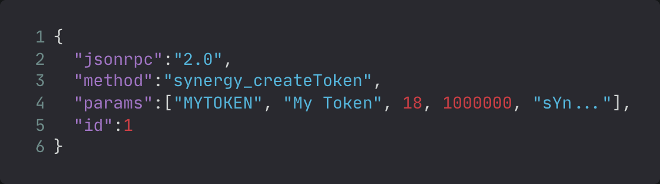
Users can create new tokens on the network:
{
"jsonrpc":"2.0",
"method":"synergy_createToken",
"params":["MYTOKEN", "My Token", 18, 1000000, "sYn..."],
"id":1
}

Parameters:
- symbol: Token symbol (unique)
- name: Token name
- decimals: Number of decimal places
- total_supply: Initial supply
- creator: Creator address

Minting Tokens
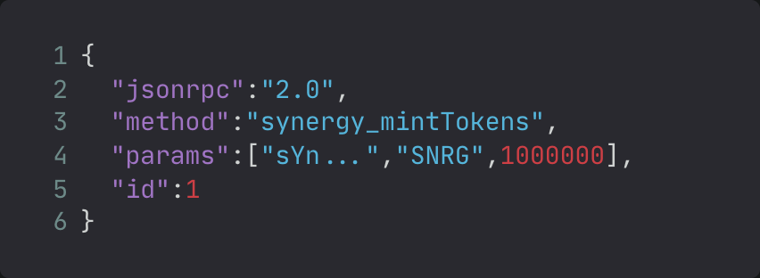
Authorized users can mint new tokens:
{
"jsonrpc":"2.0",
"method":"synergy_mintTokens",
"params":["sYn...","SNRG",1000000],
"id":1
}

Parameters:
- to: Recipient address
- token_symbol: Token to mint
- amount: Amount to mint

Burning Tokens
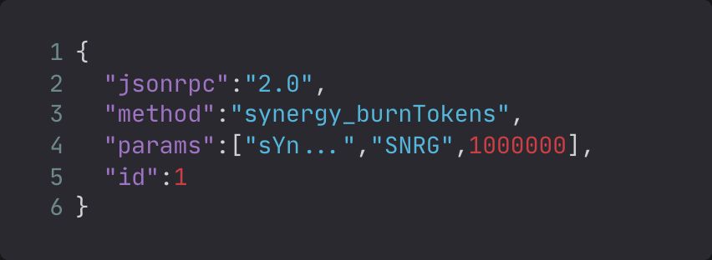
Token holders can burn their tokens:
{
"jsonrpc":"2.0",
"method":"synergy_burnTokens",
"params":["sYn...","SNRG",1000000],
"id":1
}
Parameters:
- from: Address burning tokens
- token_symbol: Token to burn
- amount: Amount to burn

Transferring Tokens
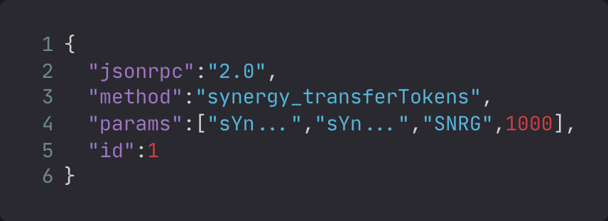
Users can transfer tokens between addresses:
{
"jsonrpc":"2.0",
"method":"synergy_transferTokens",
"params":["sYn...","sYn...","SNRG",1000],
"id":1
}
Parameters:
- from: Sender address
- to: Recipient address
- token_symbol: Token to transfer
- amount: Amount to transfer

Balance Management

Checking Balances
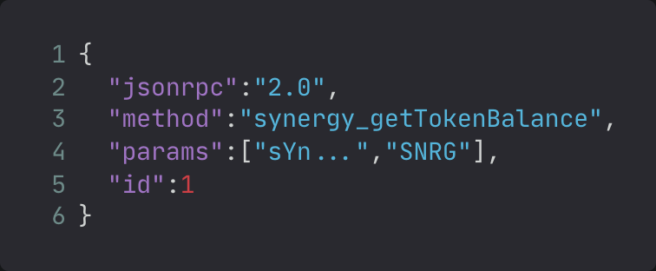
Query token balances for an address:
{
"jsonrpc":"2.0",
"method":"synergy_getTokenBalance",
"params":["sYn...","SNRG"],
"id":1
Parameters:
- address: Wallet address
- token_symbol: Token requesting balance of

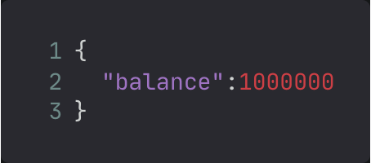
Returns:
{
"balance":1000000
}

All Balances
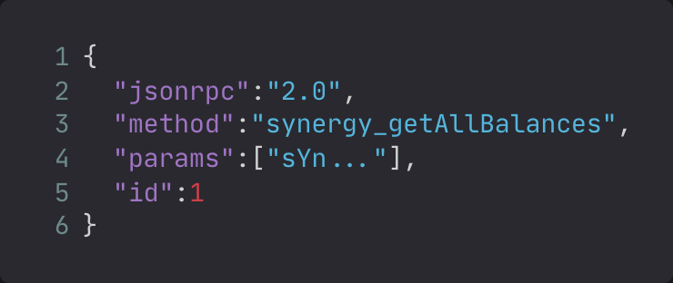
Get all token balances for an address:
{
"jsonrpc":"2.0",
"method":"synergy_getAllBalances",
"params":["sYn..."],
"id":1
}
Parameters:
- address: Wallet address

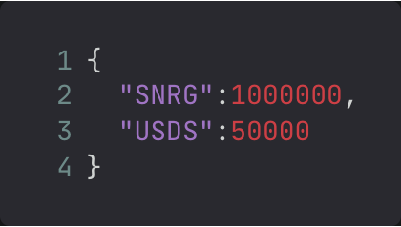
Returns:
{
"SNRG":1000000,
"USDS":50000
}

Staking System

Staking Tokens
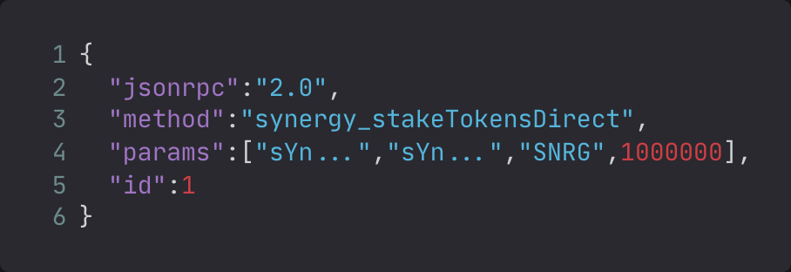
Stake tokens to validators to earn rewards:
{
"jsonrpc":"2.0",
"method":"synergy_stakeTokensDirect",
"params":["sYn...","sYn...","SNRG",1000000],
"id":1
}
Parameters:
- staker: Staker address
- validator: Validator address
- token_symbol: Token to stake
- amount: Amount to stake

Unstaking Tokens
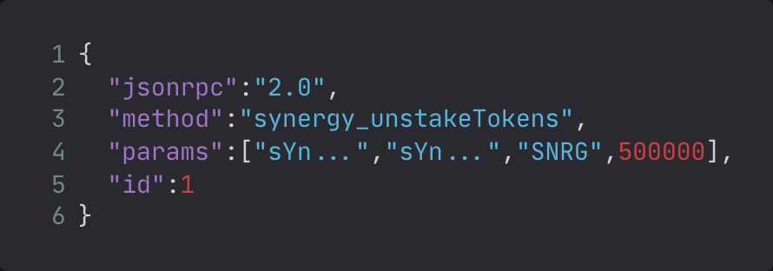
Withdraw staked tokens:
{
"jsonrpc":"2.0",
"method":"synergy_unstakeTokens",
"params":["sYn...","sYn...","SNRG",500000],
"id":1
}
Parameters:
- staker: Staker address
- validator: Validator address
- token_symbol: Token to unstake
- amount: Amount to unstake

Staking Information
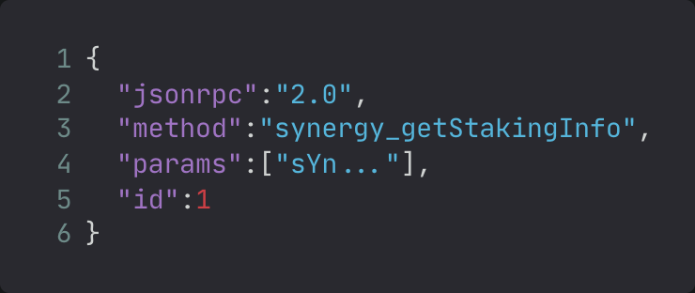
Query staking information:
{
"jsonrpc":"2.0",
"method":"synergy_getStakingInfo",
"params":["sYn..."],
"id":1
}
Parameters:
- address: Wallet address
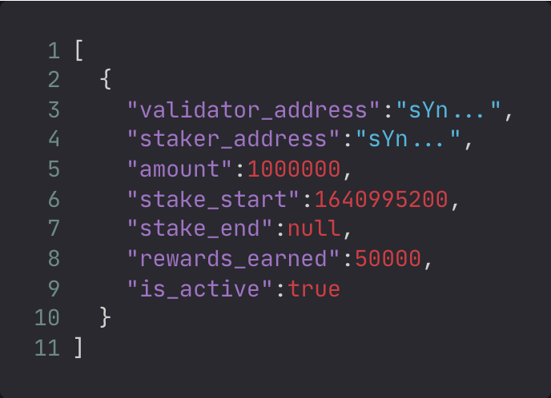
Returns:
[
{
"validator_address":"sYn...",
"staker_address":"sYn...",
"amount":1000000,
"stake_start":1640995200,
"stake_end":null,
"rewards_earned":50000,
"is_active":true
}
]

Transfer History

Transaction History
Get transfer history for an address:
{
"jsonrpc":"2.0",
"method":"synergy_getTransferHistory",
"params":["sYn...",50],
"id":1
}
Returns:
[
{
"from":"sYn...",
"to":"sYn...",
"token_symbol":"SNRG",
"amount":1000,
"fee":1000,
"timestamp":1640995200,
"tx_hash":"...",
"block_height":123
}
]

Token Statistics

Token Information
Get detailed information about all tokens:
{"jsonrpc":"2.0","method":"synergy_getTokens","params":[],"id":1}
Returns:
[{"symbol":"SNRG","name":"Synergy Coin","decimals":9,"total_supply":12000000000000000000000000000,"max_supply":12000000000000000000000000000,"mintable":false,"burnable":true,"created_at":1640995200,"creator":"genesis"}]

Token Statistics
Get comprehensive token statistics:
{"jsonrpc":"2.0","method":"synergy_getTokenStats","params":[],"id":1}
Returns:
[{"symbol":"SNRG","name":"Synergy Coin","total_supply":12000000000000000000000000000,"total_staked":500000000000000000000,"holders":25}]

Security Features

Balance Validation
All token operations include balance validation to prevent:
- Insufficient funds errors
- Double-spending
- Invalid token operations

Access Control
- Only authorized addresses can mint tokens
- Burn operations require sufficient balance
- Transfer operations validate sender balance

State Management
Token state is managed through:
- Persistent storage across node restarts
- Atomic operations to prevent corruption
- Rollback capabilities for failed operations

Use Cases

DeFi Applications
The token system supports:
- Creating custom tokens for DApps
- Staking mechanisms for yield farming
- Token swaps and liquidity pools

Gaming and NFTs
- In-game currencies
- NFT marketplaces
- Gaming rewards and achievements

Enterprise Solutions
- Corporate tokens
- Supply chain tracking
- Digital asset management

Best Practices

Token Creation
- Choose appropriate decimal places (18 is standard)
- Set reasonable max supply limits
- Consider making tokens mintable for future expansion
- Use descriptive names and symbols

Staking
- Research validators before staking
- Consider lock-up periods
- Monitor reward distribution
- Diversify across multiple validators

Security
- Never share private keys
- Verify all transaction details before signing
- Use hardware wallets for large amounts
- Keep software updated

Troubleshooting

Common Issues
"Insufficient balance": Ensure you have enough tokens for the operation "Token not found": Verify the token symbol is correct "Unauthorized": Check if you have permission for the operation "Network error": Verify node connectivity

Getting Help
For technical support:
- Check the troubleshooting guide
- Review API documentation
- Contact the development team

Future Enhancements
Planned features for the token system:
- Cross-chain token transfers
- Advanced staking mechanisms
- Token governance features
- Automated market makers
- Layer 2 scaling solutions

